**Memo Board - Front End - Web**

*Purpose of this document is to tell about the functionalities implemented in "Memo Board" project.*

**Technologies used:**\* Html  
* CSS  
* JavaScript  
* ReactJS  
* External libraries, react.js, react-dom.js, browser.min.js.

Index.html is entry point of the project. I strongly recommend using Google chrome for better experience.

**Manual test cases are taken care on below points:**

|  |  |  |  |
| --- | --- | --- | --- |
| **Test Case #** | **Title** | **Status** | **Ramark** |
| 1 | Ideas should be displayed as tiles | Done |  |
| 2 | Height and width of 150px and a 10px margin | Done |  |
| 3 | Aligned horizontally to fit screen width | Done |  |
| 4 | There should be a button that can be clicked to add a new blank idea | Done |  |
| 5 | The title field should be focused to prompt the user to begin typing. | Done |  |
| 6 | A request should be made to a backend REST service to get an id for the new idea, as well as the created_date. | Done partially | Need to implement service calls |
| 7 | The title and body fields should be editable. | Done |  |
| 8 | These fields should have no border when blurred, but a solid light grey border when they are focused. | Done |  |
| 9 | Blurring any of these fields should trigger an update request to the backend REST service. | Done partially | Need to implement service calls |
| 10 | Each tile should have a delete icon which should only be visible when hovering over the tile. | Done |  |
| 11 | Clicking delete icon should remove the idea and make an update request to the backend REST service | Done partially | Need to implement service calls |
| 12 | Implement sorting that changes with a dropdown. The sort options should be title and created_date. | Done |  |
| 13 | Implement a character counter that is displayed when the body field is edited and the remaining character count is <15. | Done |  |
| 14 | Hide the counter when the remaining characters count is >15. | Done |  |
| 15 | Use localStorage to persist the ideas so that they persist after a page refresh. | Done |  |
| 16 | Implement a notification to tell the user that edits have been successfully saved. | Done |  |

**Screen shots:**

**1. Default view of the dashboard.**

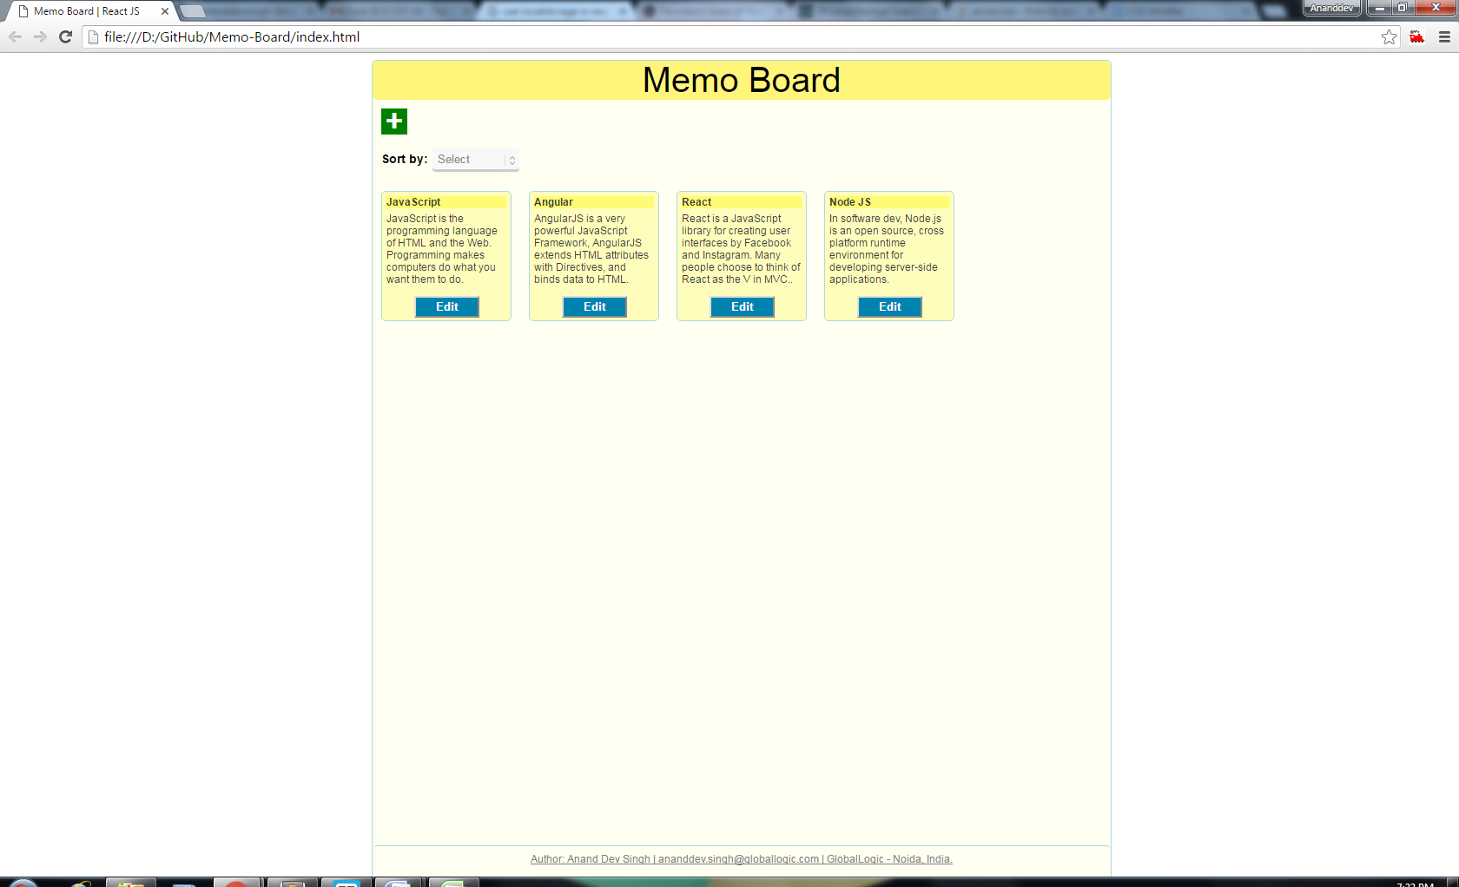

**2. On clicking "+" symbol, It will expand Idea/Memo submission form.**

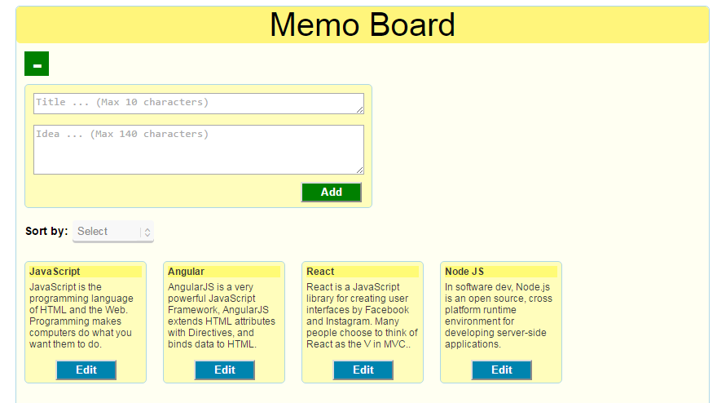

**3. Idea/Memo submission form have limit, on title (10 characters) and Idea (140 characters).**

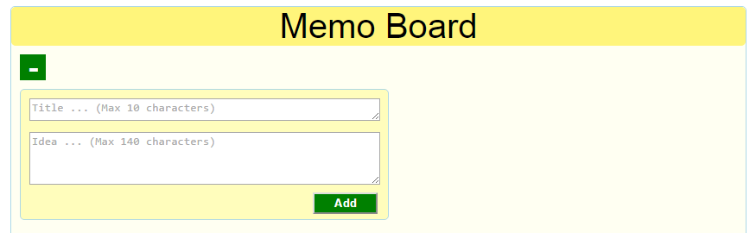

**4. Idea body field alert if only < 15 more characters allowed.**

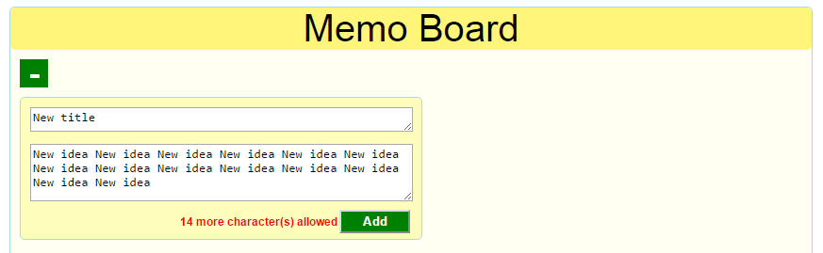

**5. Notify on successfully saving of message. Fade out automatically after 5 seconds.**

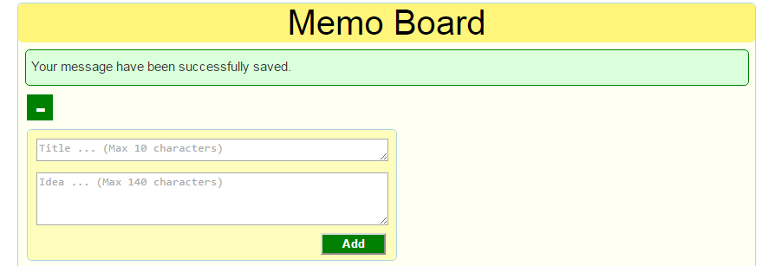

**6. Sort by dropdown containing "Title" and "Created date" as filter options.**

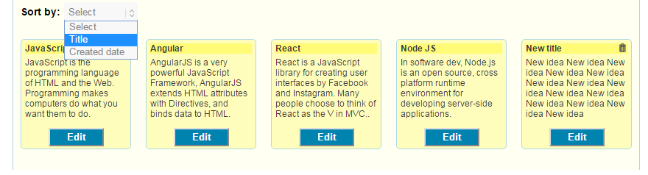

**7. Saved tiles are editable and it will add "2px solid gray" border at field focus.**

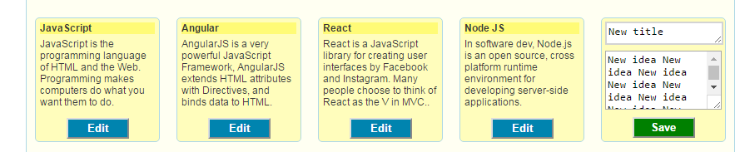

**8. On successfully saving, it will alert with message and also persist memo in localstorage.**

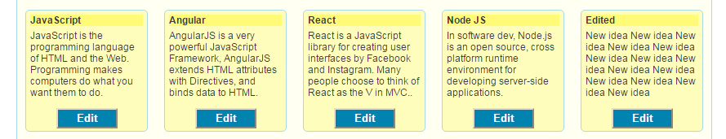

**9. Delete icon at hover of tiles.**

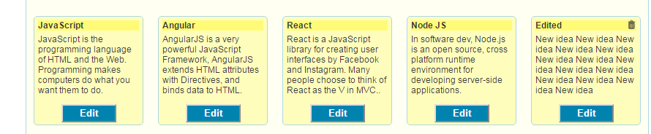

**10. On clicking delete icon, it will delete the tile.**

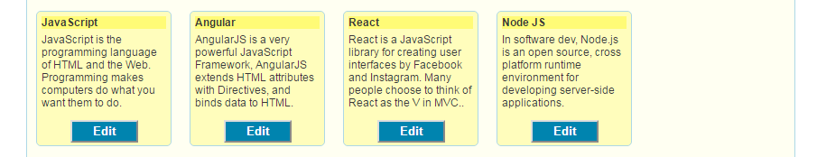

**Note: As I am having the constraint of implementing the REST API, I have used alert messages just for intimation of use of REST services. It is commented at code where we can need to write the service calls code.**

**(Anand Dev Singh)**

**END**